

ETHICAL HACKING ASSIGNMENT REPORT
STUDENT INFORMATION
NAME: KELVIN KIPNGETICH
ADMISSION NO: BSCCS/2024/43869
COURSE: ETHICAL HACKING / CYBERSECURITY
TOOL USED: NMAP
PLATFORM: PARROT OS
DATE: 3RD JUNE 2026
LECTURER: MICHAEL NYORO
YEAR: 4 SEM: 2

PROJECT DETAILS
Project Title: Web Vulnerability Scanning and Foot printing Analysis
Selected Technologies: Kali Linux, Nmap

Table of Contents
ETHICAL HACKING AND COUNTER MEASURES 4
WEEK 1 4
INSTALLATION 4
UPDATING THE APPLIANCE 5
WEEK 2 6
WEB VULNERABILLITY SCANNING 6
WEEK 3 7
DNS FOOTPRINTING 7
PORT SCANNING 7
MOTIVATION 8
WEEK 4 8
COMPANY & DOMAIN INFORMATION 8
EMAIL PATTERNS 9
PORT SCANNING 10
DISCOVERING SUBDOMAINS 11
DETECTING TECHNOLOGIES & SERVICES 12
ENUMERATE USERS 12
SECURITY RISKS 12

ETHICAL HACKING AND COUNTER MEASURES

WEEK 1

INSTALLATION
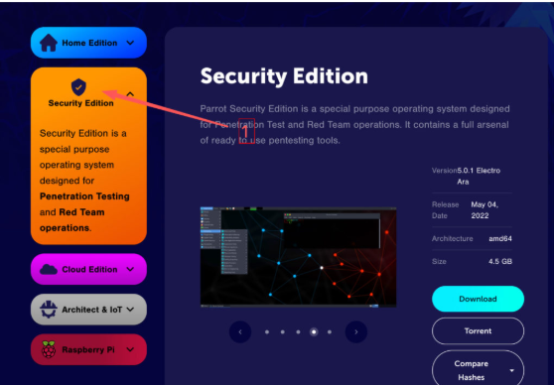
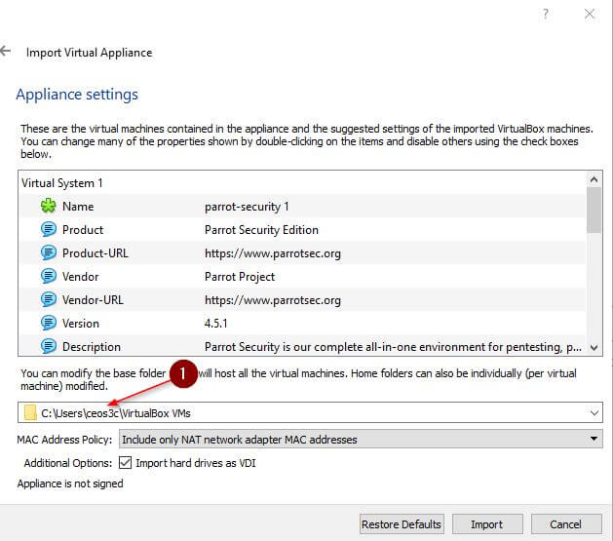
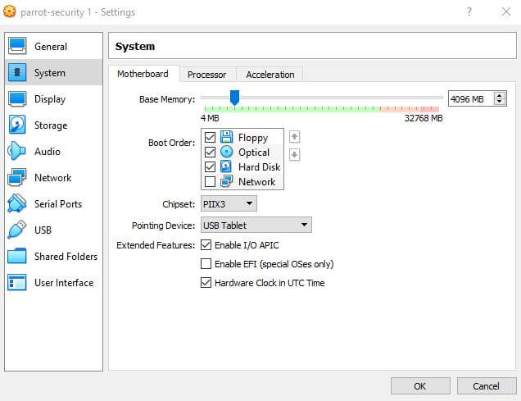

UPDATING THE APPLIANCE
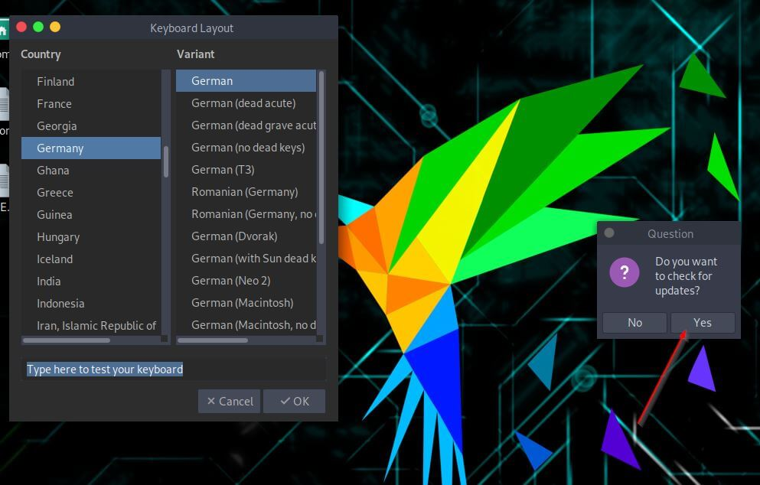

Week 1 — Installation & Updating the Appliance The first week focused on setting up the working environment by installing the necessary tools and platform. Keeping the appliance updated ensures the latest security patches and tool versions are in place. A properly configured environment is the foundation for all subsequent ethical hacking activities.

WEEK 2

WEB VULNERABILLITY SCANNING
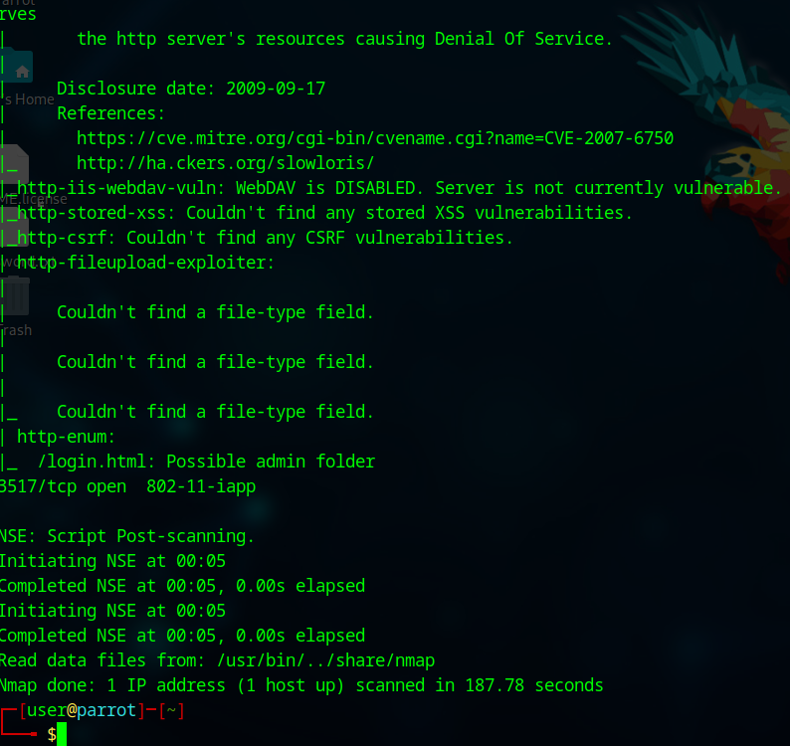

Week 2 — Web Vulnerability Scanning The second week involved actively scanning web targets to identify potential security weaknesses and misconfigurations. This phase highlights how automated tools can quickly surface exploitable entry points in a web application. Understanding scan results is critical for distinguishing real vulnerabilities from false positives.

WEEK 3

DNS FOOTPRINTING
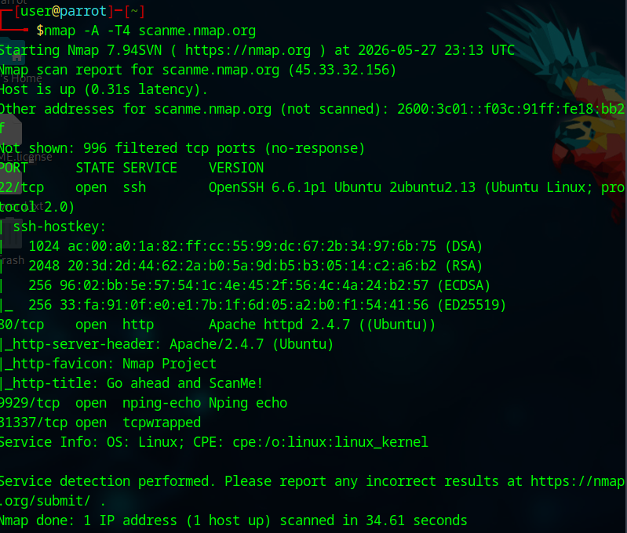

PORT SCANNING
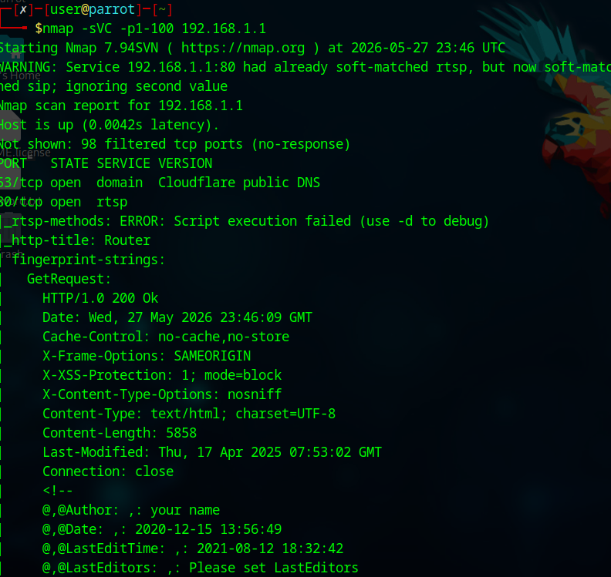

Week 3 — DNS Footprinting, Port Scanning & Motivation Week three expanded reconnaissance to include DNS enumeration and port scanning, mapping out the attack surface of a target. The motivation section reinforced that every exposed record, port, or email pattern represents a real security risk. Key lessons drawn include using CDNs to hide origin IPs, restricting zone transfers, and closing unnecessary ports.

MOTIVATION
Every open port, DNS record, email pattern, and exposed technology reveals a potential attack surface, proving that obscurity is not security. Key lessons include hiding origin IPs with CDNs, restricting DNS zone transfers, using unpredictable email formats, closing unnecessary ports, and removing version-disclosing headers. However, major challenges were avoiding false positives in automated vulnerability scans, distinguishing active subdomains from stale DNS entries, and consistently securing all assets without breaking legitimate services. Additionally, ethical testing requires careful scoping to prevent unintended disruption, while defenders must balance usability with strict error-message standardization to block user enumeration.

WEEK 4

COMPANY & DOMAIN INFORMATION
- IP ADDRESS & HOSTING
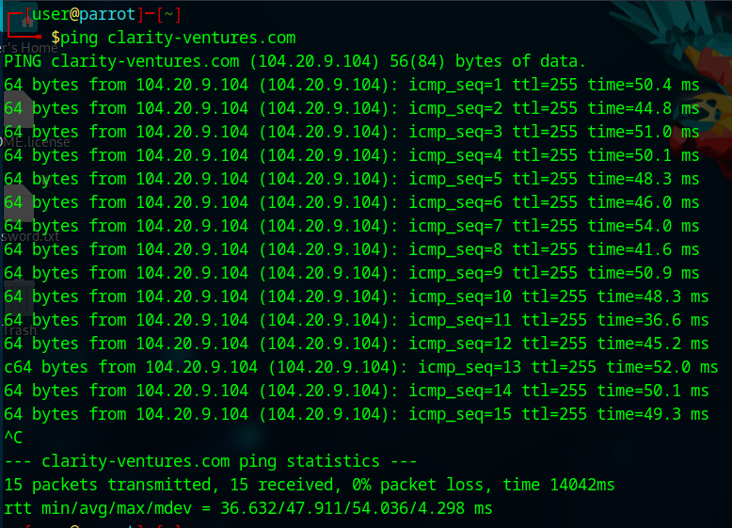
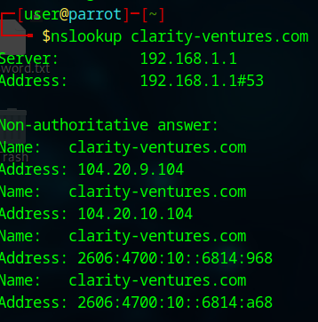

EMAIL PATTERNS
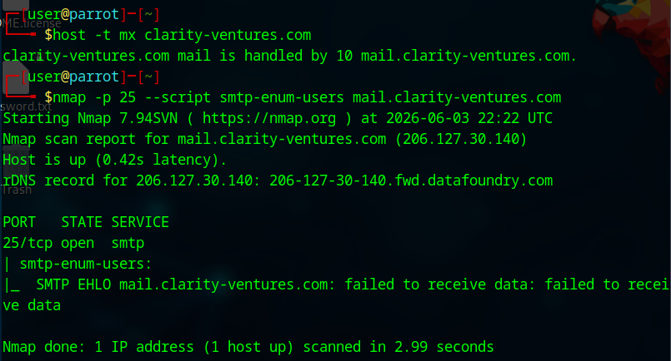

PORT SCANNING
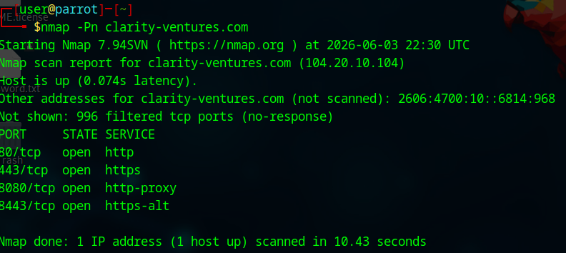

DISCOVERING SUBDOMAINS
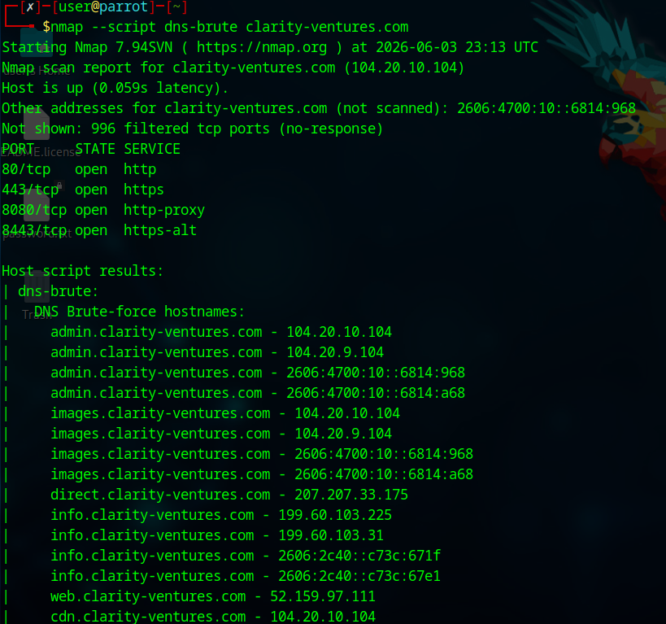
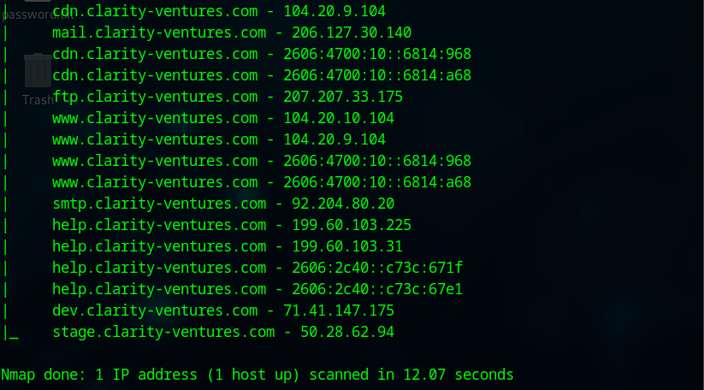

DETECTING TECHNOLOGIES & SERVICES
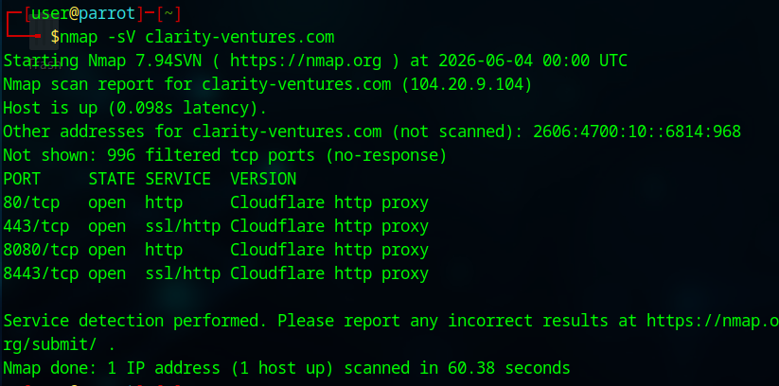

ENUMERATE USERS
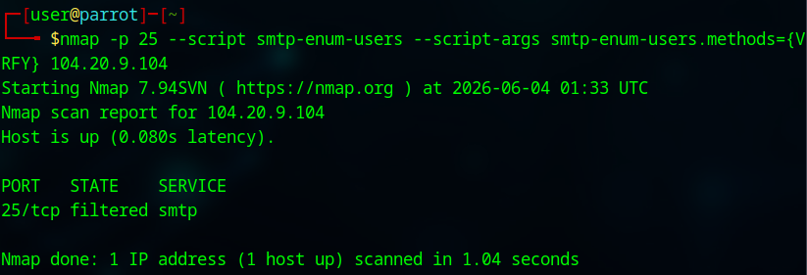

Week 4 — Company & Domain Analysis, Security Risks The final week brought all recon techniques together — IP lookup, email patterns, subdomain discovery, technology fingerprinting, and user enumeration — applied to a real company domain. Each finding was tied to a concrete security risk, from phishing enablement to DDoS targeting and brute-force attacks. The week concluded with a sobering reminder that the recon document itself, if leaked, becomes a ready-made attack blueprint.

SECURITY RISKS
Exposed IP & Hosting Information
Risk: Attackers can pinpoint the hosting provider and IP ranges, making DDoS attacks, infrastructure mapping, or exploiting known vulnerabilities in that host easier.
Email Pattern Discovery
Risk: Revealing email formats (e.g., first.last@company.com) enables targeted phishing, social engineering, or credential stuffing attacks.
Open Ports & Services
Risk: Unnecessary or insecure open ports (e.g., SSH, RDP, outdated database ports) increase the attack surface, potentially allowing remote access, lateral movement, or exploitation of unpatched services.
Subdomain Enumeration
Risk: Forgotten, unmaintained, or poorly secured subdomains (like dev, test, or admin panels) may expose internal apps, staging data, or APIs to external attackers.
Technology & Service Fingerprinting
Risk: Knowing specific software stacks (web servers, CMS, frameworks, libraries) lets attackers search for known CVEs or default configurations to exploit.
User Enumeration via Nmap Scripts
Risk: Attackers can validate valid usernames (e.g., from SMTP, RDP, or SMB services), which dramatically increases the success rate of brute‑force or password spraying attacks.
Internal Reconnaissance Data Leakage
Risk: The very existence of this document (combining multiple recon outputs) suggests sensitive network mapping data has been collected and stored without adequate protection—if leaked, it becomes a ready‑made attack blueprint.

